**My SQL -task1**

**SQL Lesson 1: SELECT queries 101**

1. Select Title from movies;
2. Select Director from movies;
3. Select Title,Director from movies;
4. Select title,year from movies;
5. Select * from movies;

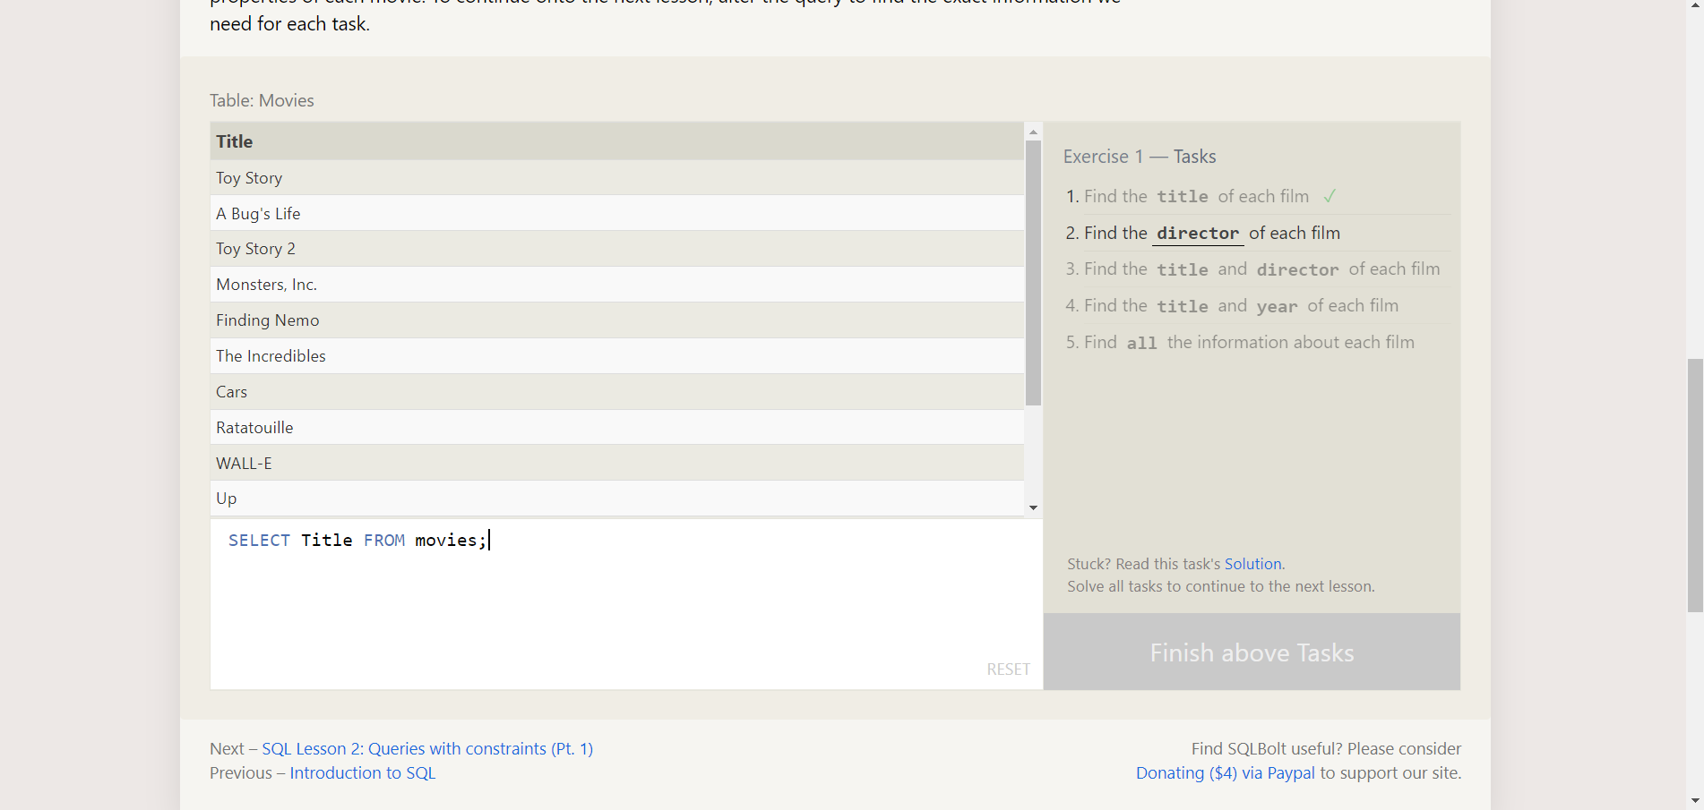

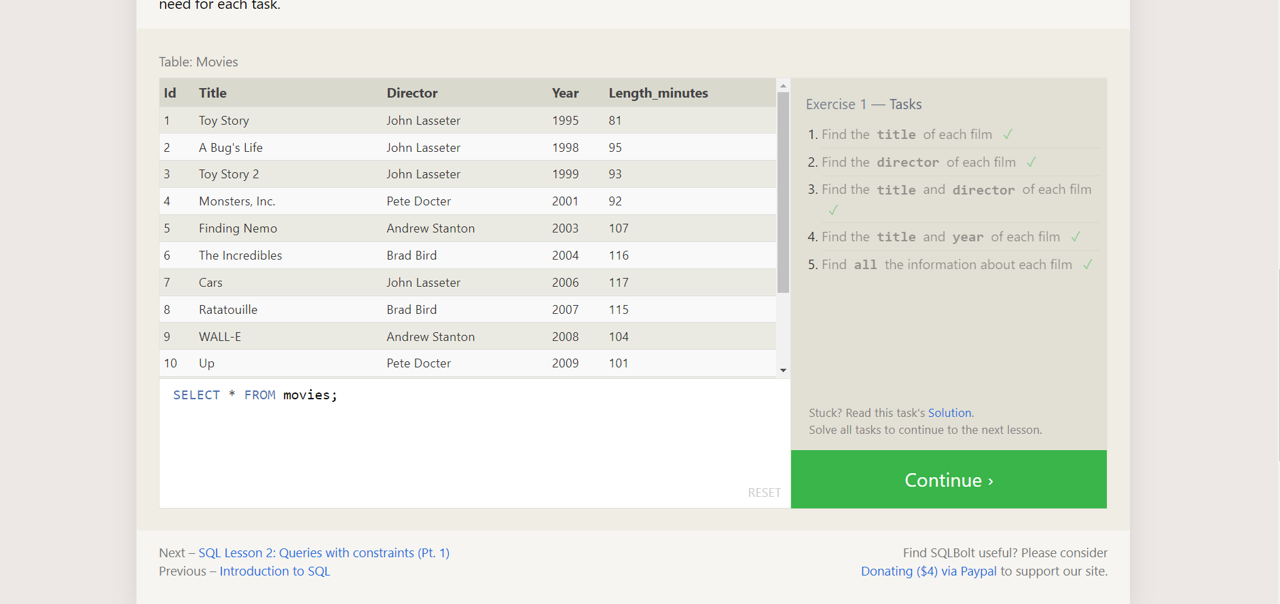

**SQL Lesson 2: Queries with constraints (Pt. 1)**

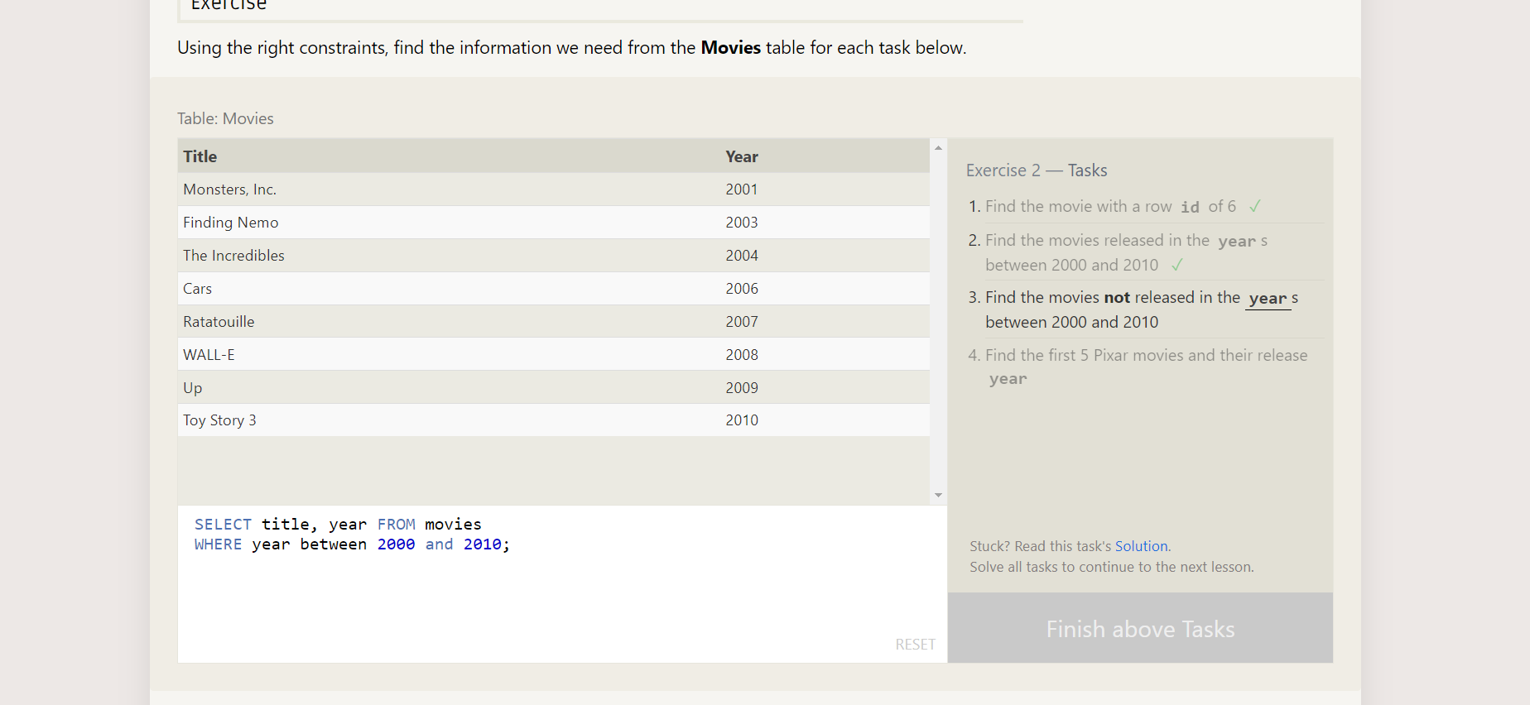

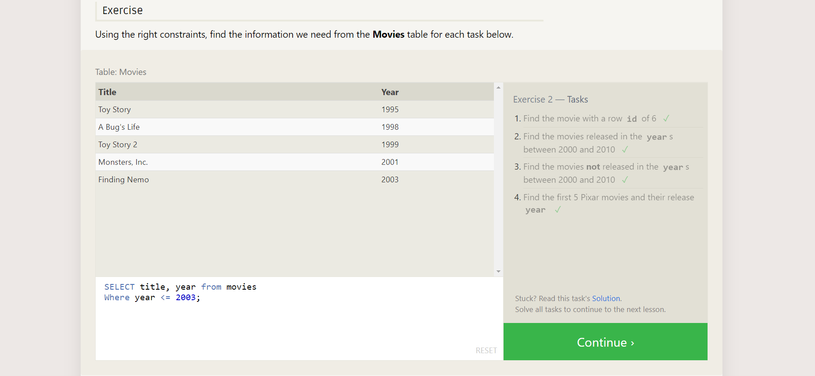

**SQL Lesson 3: Queries with constraints (Pt. 2)**

Ex3:

1. SELECT title, director FROM movies

WHERE title LIKE "Toy Story%";

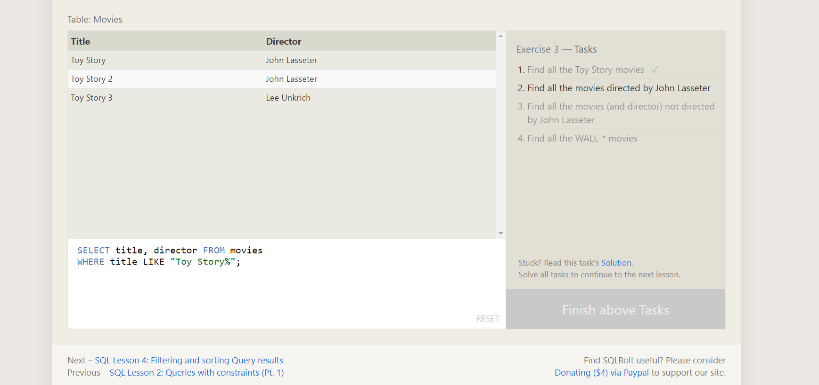

2. SELECT title FROM movies

WHERE director='John Lasseter';

3. SELECT title FROM movies

WHERE not like director='John Lasseter';

4. SELECT * FROM movies

WHERE title LIKE "WALL-_";

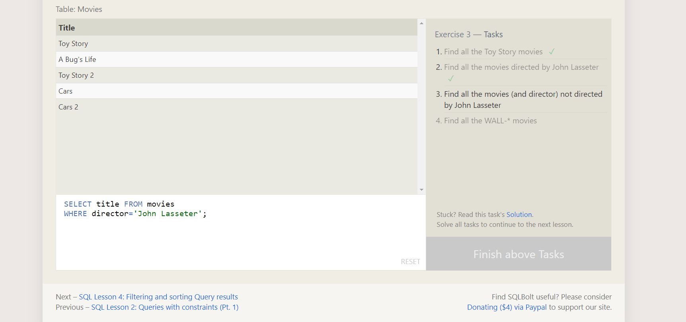

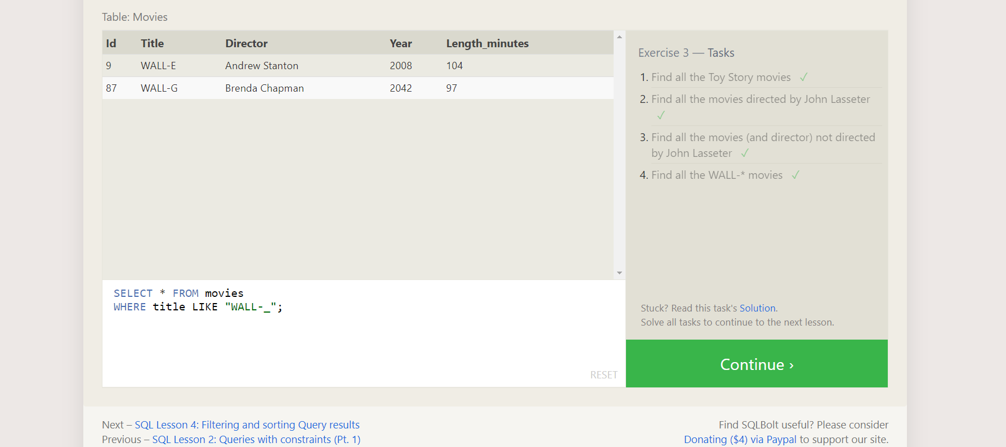

**SQL Lesson 4: Filtering and sorting Query results**

1. SELECT DISTINCT director FROM movies

ORDER BY director ASC;

2. SELECT title,year FROM movies

ORDER BY year desc

LIMIT 4;

3. SELECT title FROM movies

ORDER BY title asc

LIMIT 5;

4. SELECT title FROM movies

Order BY title asc

Limit 5 Offset 5;

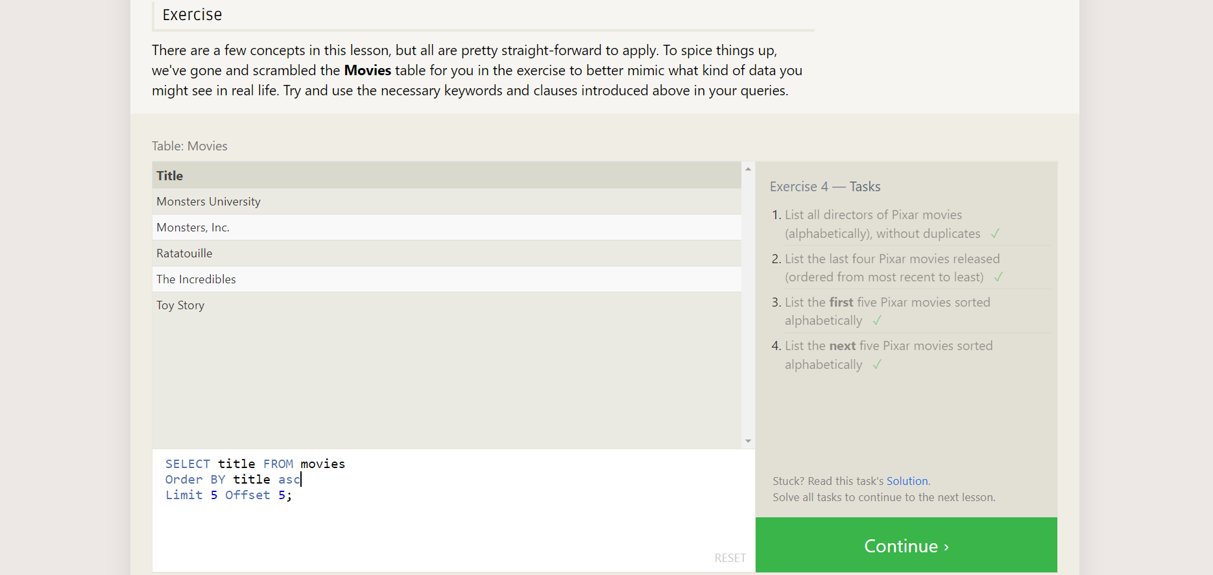

**SQL Review: Simple SELECT Queries**

1.

2. SELECT city, latitude FROM north_american_cities

WHERE country = "United States"

ORDER BY latitude DESC;

3. SELECT city, longitude FROM north_american_cities

WHERE longitude < -87.629798

ORDER BY longitude ASC;

4. SELECT city, population FROM north_american_cities

WHERE country LIKE "Mexico"

ORDER BY population DESC

LIMIT 2;

5. SELECT city, population FROM north_american_cities

WHERE country LIKE "United States"

ORDER BY population DESC

LIMIT 2 offset 2;

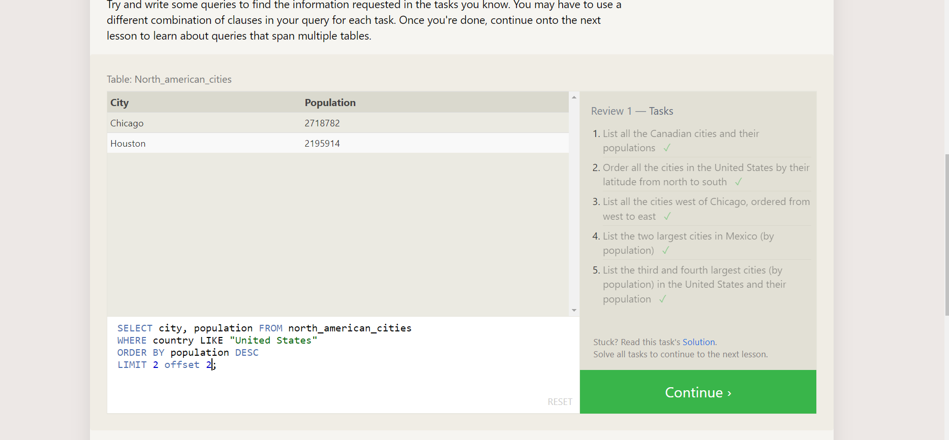

**SQL Lesson 6: Multi-table queries with JOINs**

1. SELECT title, domestic_sales, international_sales

FROM movies

JOIN boxoffice

ON movies.id = boxoffice.movie_id;

2. SELECT title, domestic_sales, international_sales

FROM movies

JOIN boxoffice

ON movies.id = boxoffice.movie_id

WHERE international_sales > domestic_sales;

3. SELECT title,Rating

FROM movies

JOIN boxoffice

ON movies.id = boxoffice.movie_id

order by Rating desc;

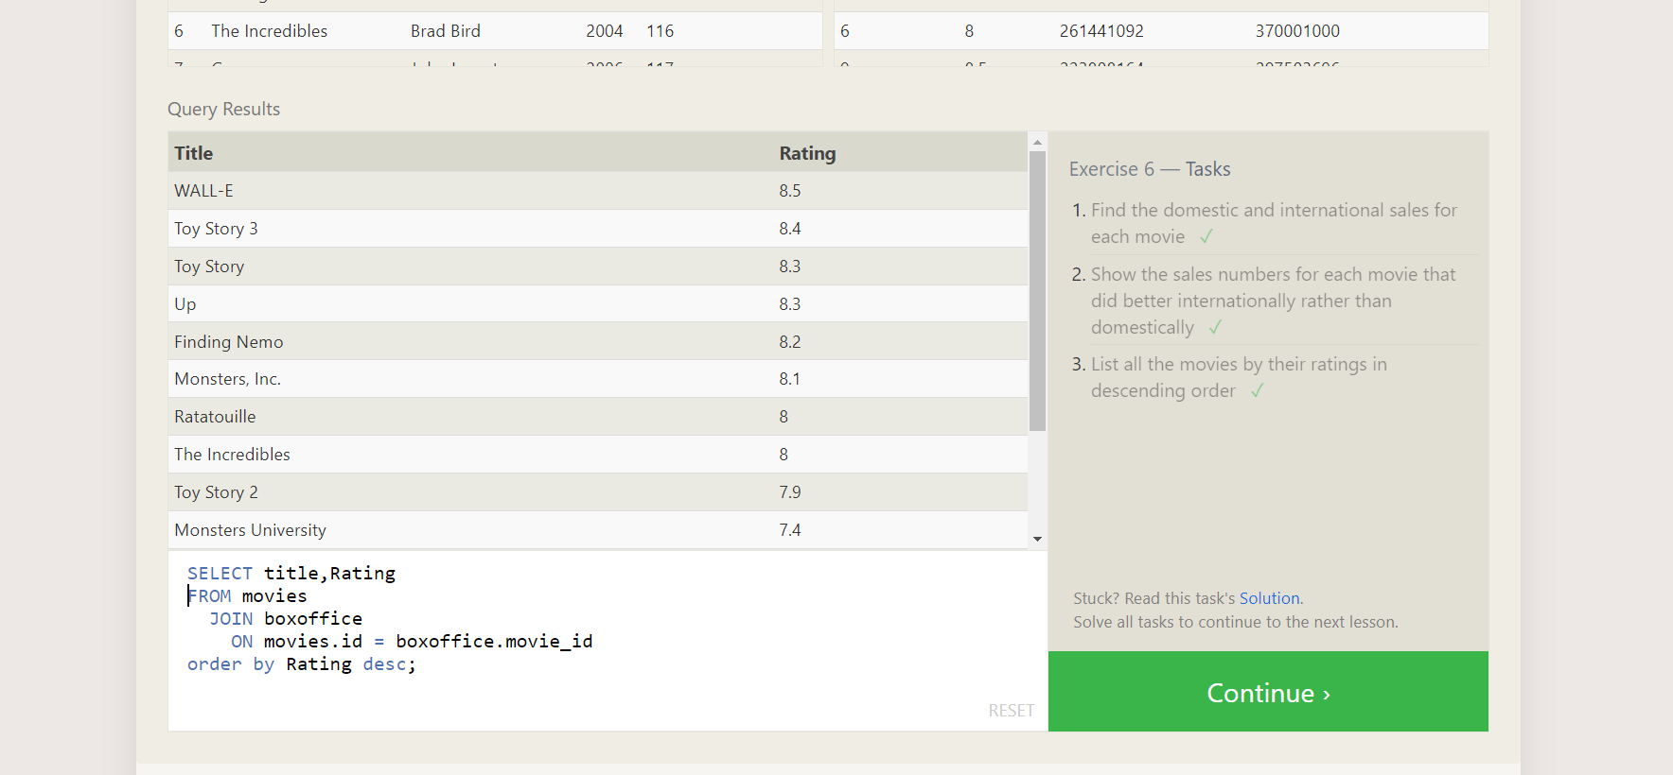

**SQL Lesson 7: OUTER JOINs**

1. SELECT DISTINCT building FROM employees;
2. SELECT * FROM buildings;
3. SELECT DISTINCT building_name, role

FROM buildings

Left join employees

on building_name = building;

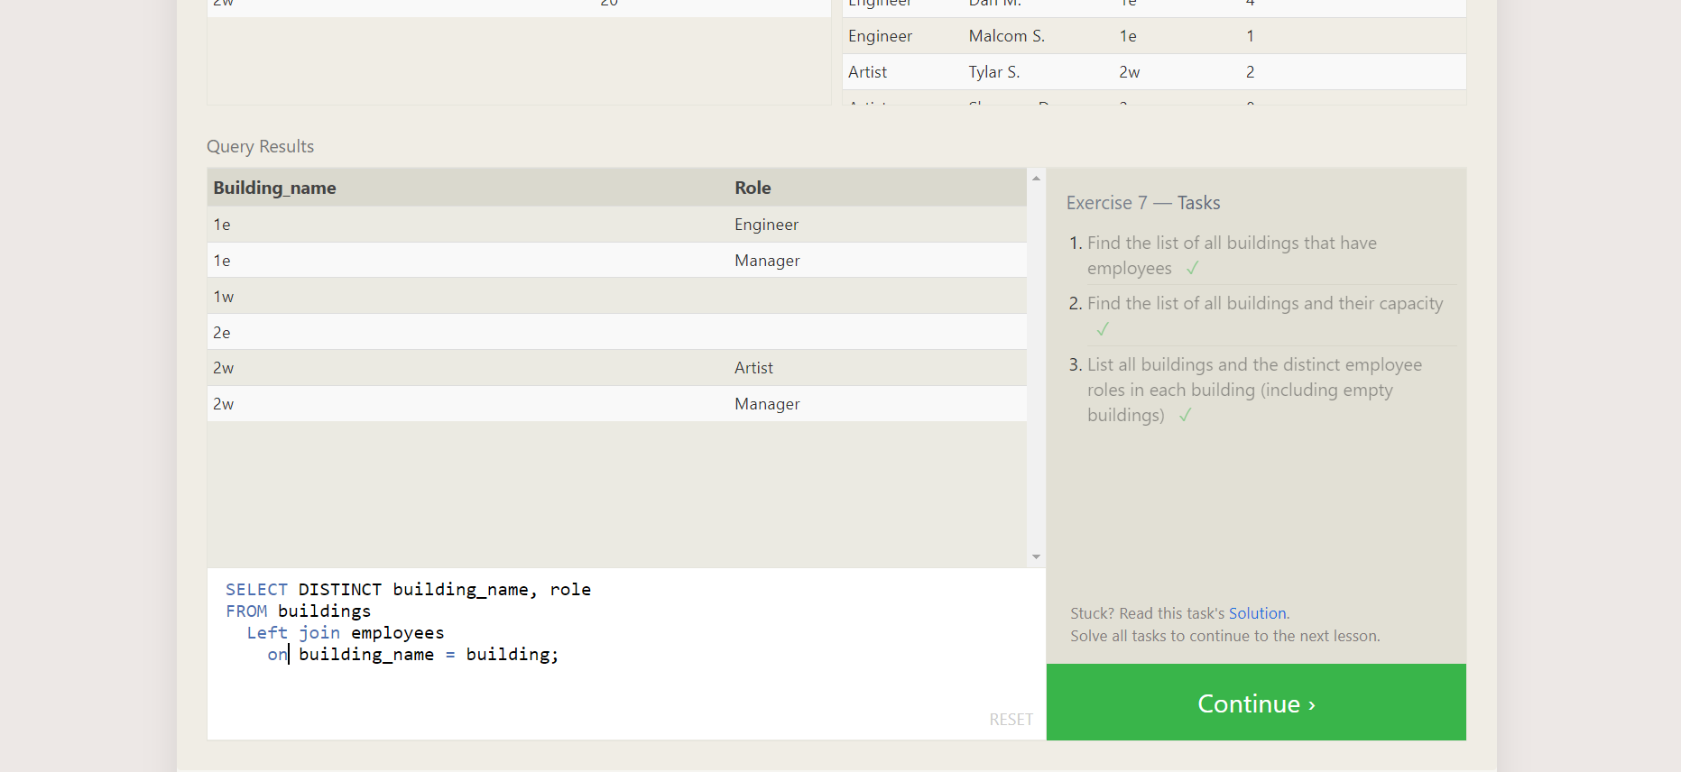

**SQL Lesson 8: A short note on NULLs**

1. SELECT name, role FROM employees

WHERE building IS NULL;

2. SELECT DISTINCT building_name

FROM buildings

LEFT JOIN employees

ON building_name = building

WHERE role is NULL;

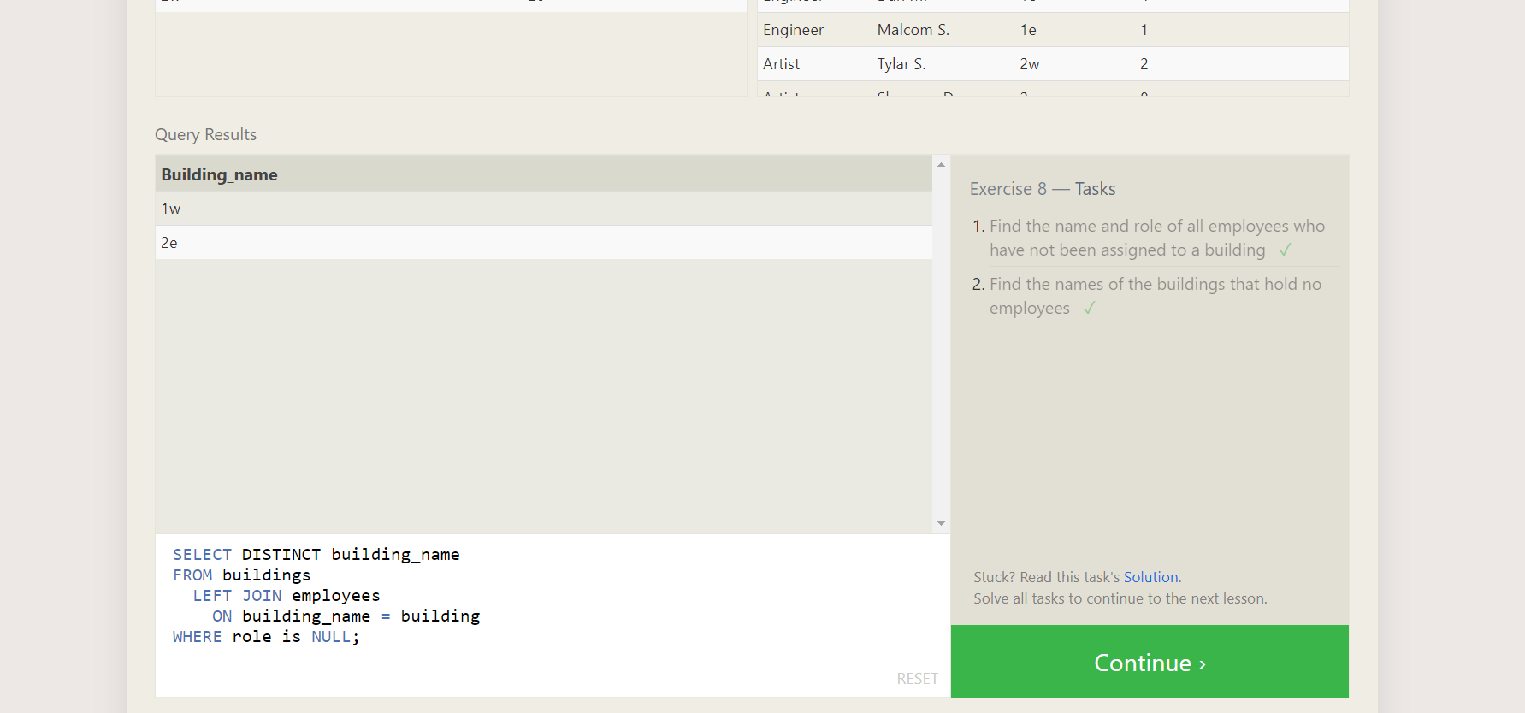

**SQL Lesson 9: Queries with expressions**

1. SELECT title, (domestic_sales + international_sales) / 1000000 AS gross_sales_millions

FROM movies

JOIN boxoffice

ON movies.id = boxoffice.movie_id;

2. SELECT title, rating * 10 AS rating_percent

FROM movies

JOIN boxoffice

ON movies.id = boxoffice.movie_id;

3. SELECT title, year

FROM movies

WHERE year % 2 = 0;

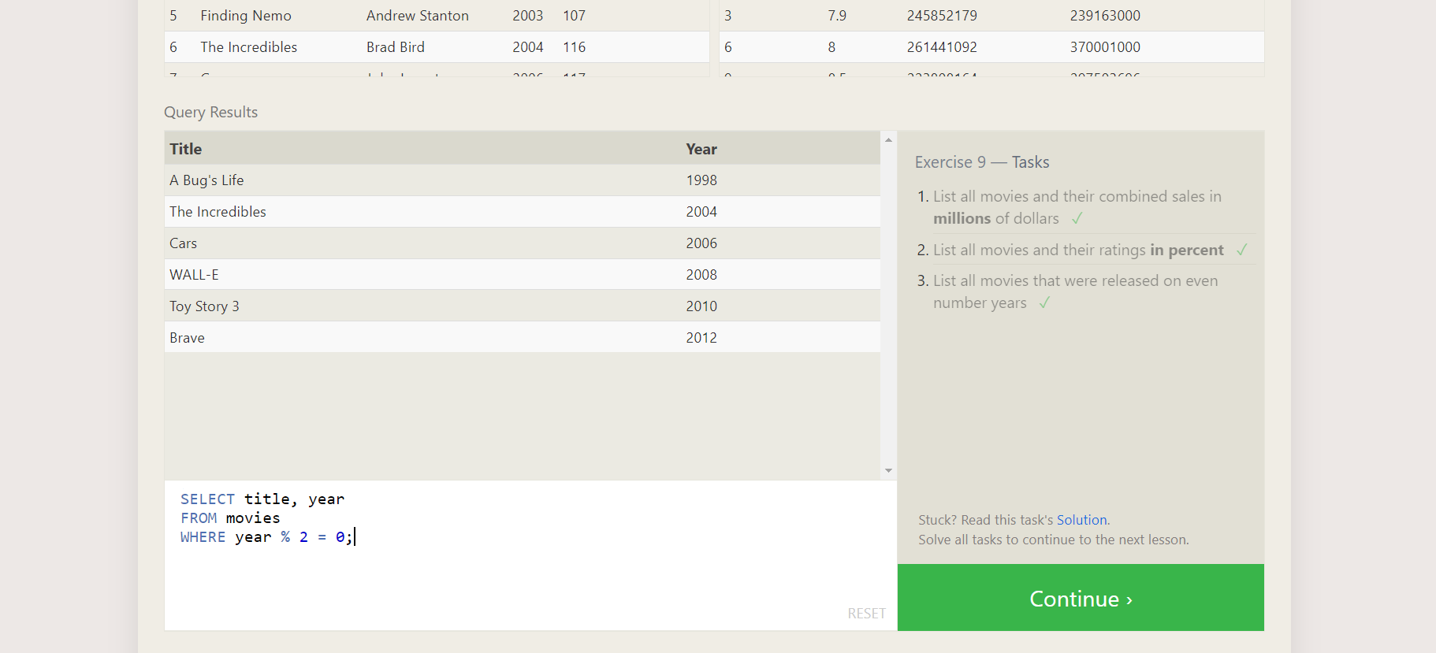

**SQL Lesson 10: Queries with aggregates (Pt. 1)**

1. SELECT MAX(years_employed) as Max_years_employed

FROM employees;

2. SELECT role, AVG(years_employed) as Average_years_employed

FROM employees

GROUP BY role;

3. SELECT building, SUM(years_employed) as Total_years_employed

FROM employees

GROUP BY building;

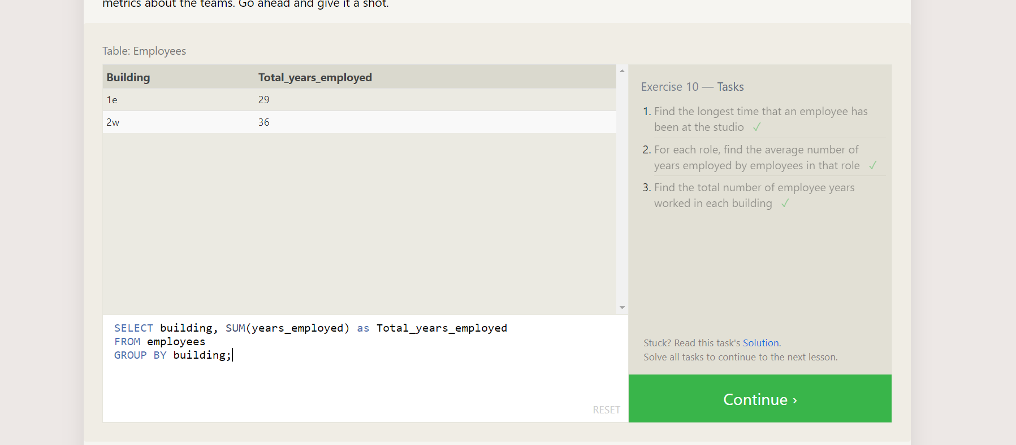

**SQL Lesson 11: Queries with aggregates (Pt. 2)**

1. SELECT role, COUNT(*) as Number_of_artists

FROM employees

WHERE role = "Artist";

2. SELECT role, COUNT(*) as Number_of_artists

FROM employees

WHERE role = "Artist";

3. SELECT role, SUM(years_employed)

FROM employees

GROUP BY role

HAVING role = "Engineer";

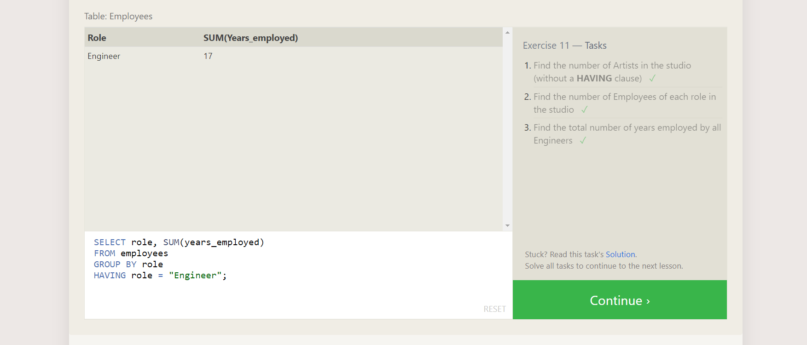

**SQL Lesson 12: Order of execution of a Query**

1. SELECT director, COUNT(id) as Num_movies_directed

FROM movies

GROUP BY director;

2. SELECT director, SUM(domestic_sales + international_sales) as Cumulative_sales_from_all_movies

FROM movies

INNER JOIN boxoffice

ON movies.id = boxoffice.movie_id

GROUP BY director;

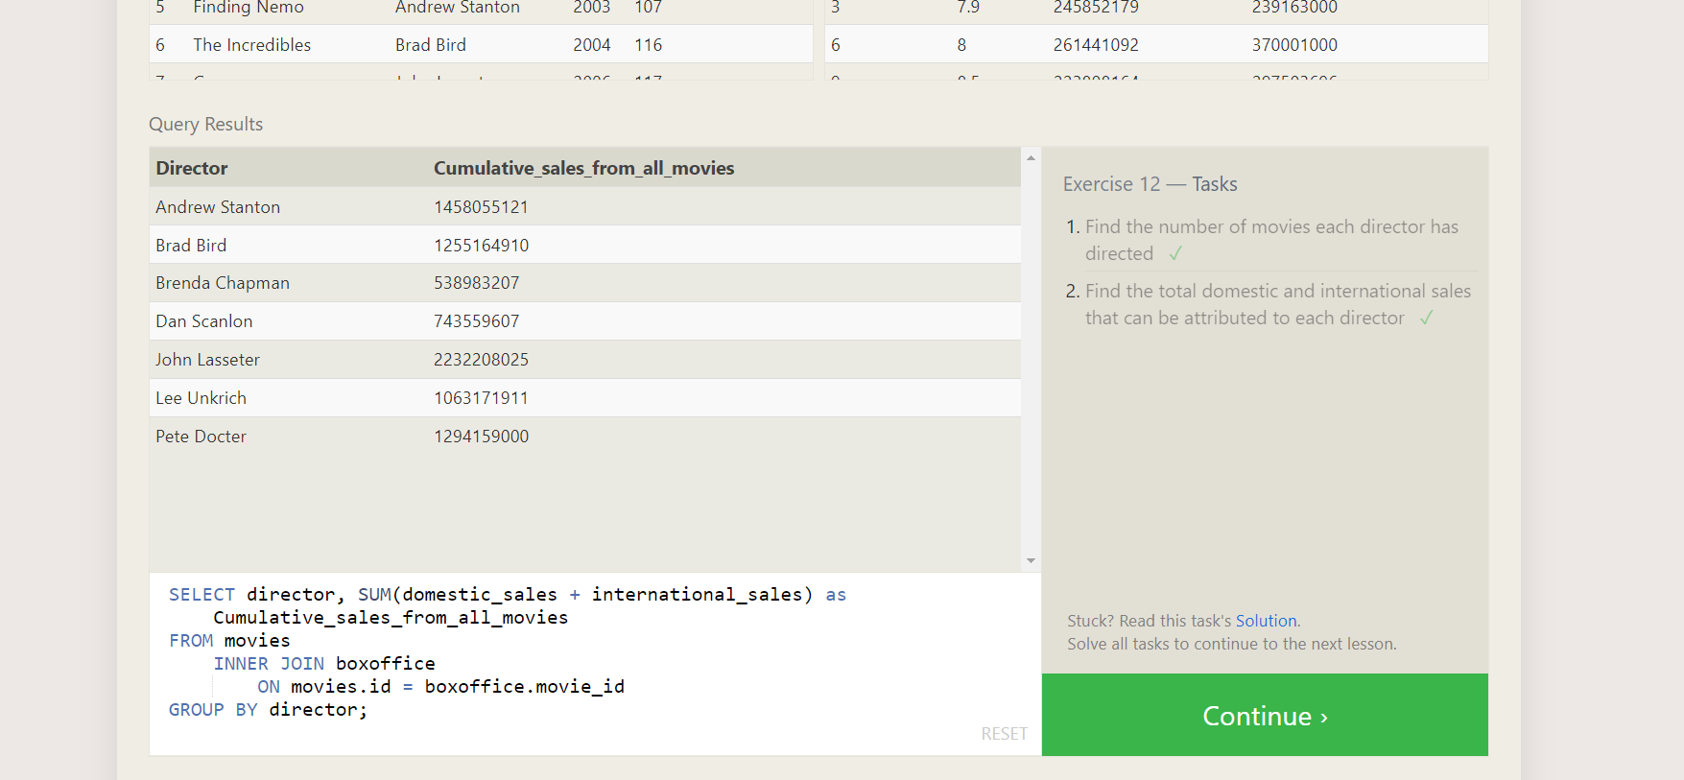

**SQL Lesson 13: Inserting rows**

1. INSERT INTO movies VALUES (4, "Toy Story 4", "Brad Bird", 2015, 90);
2. INSERT INTO boxoffice VALUES (4, 8.7, 340000000, 270000000);

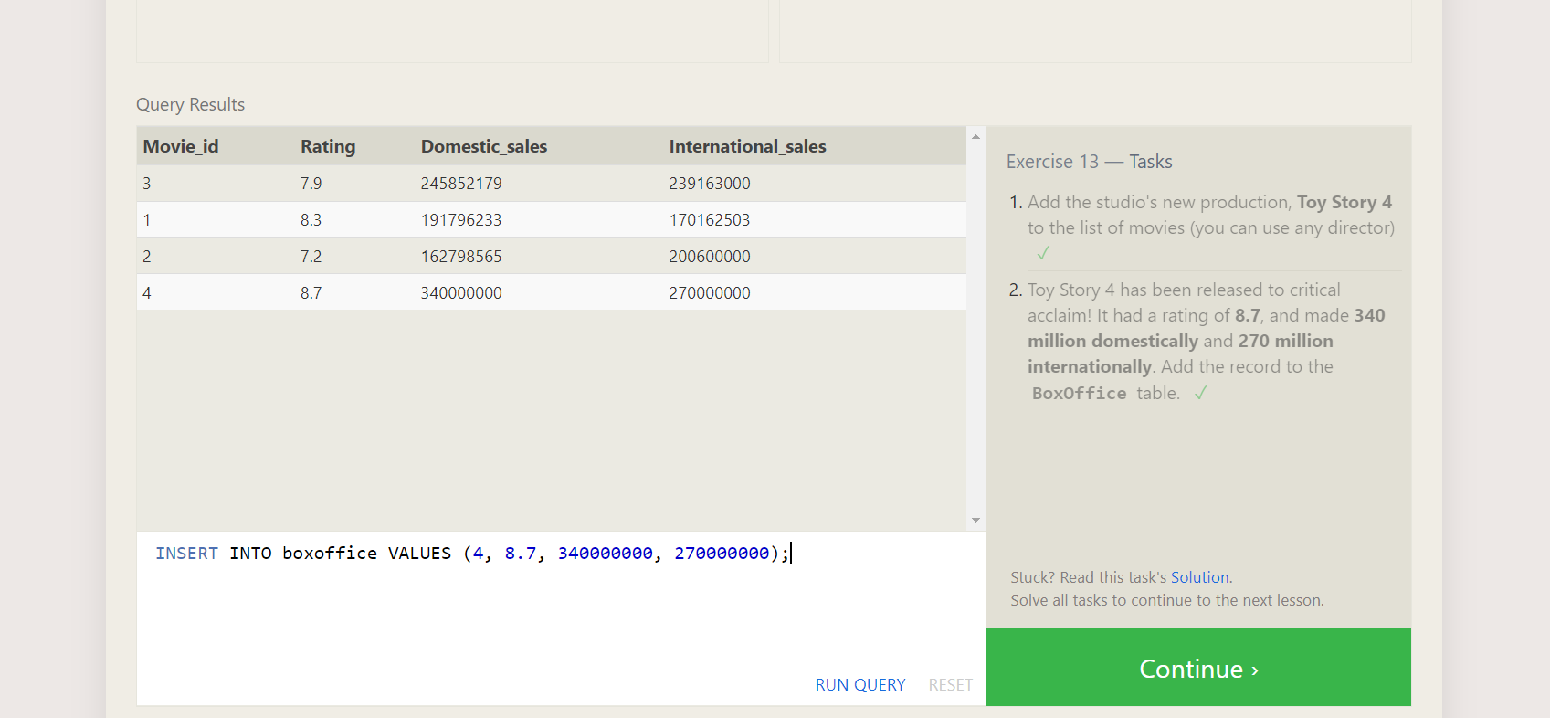

**SQL Lesson 14: Updating rows**

1. update Movies set director='John Lasseter' where title="A Bug's Life"
2. UPDATE movies

SET year = 1999

WHERE id = 3;

1. UPDATE movies SET title = "Toy Story 3", director = "Lee Unkrich" WHERE id = 11;

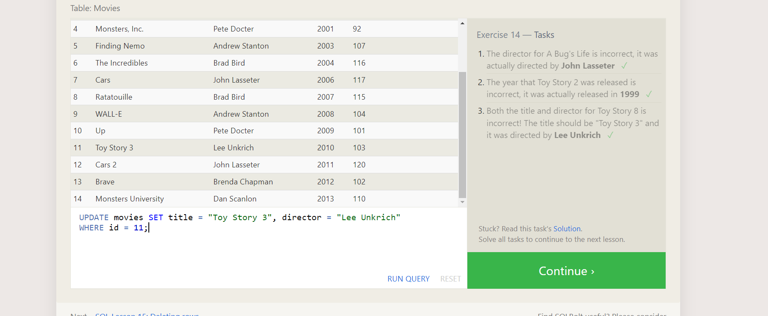

**SQL Lesson 15: Deleting rows**

1. delete from Movies where year<2005;
2. delete from Movies where director='Andrew Stanton';

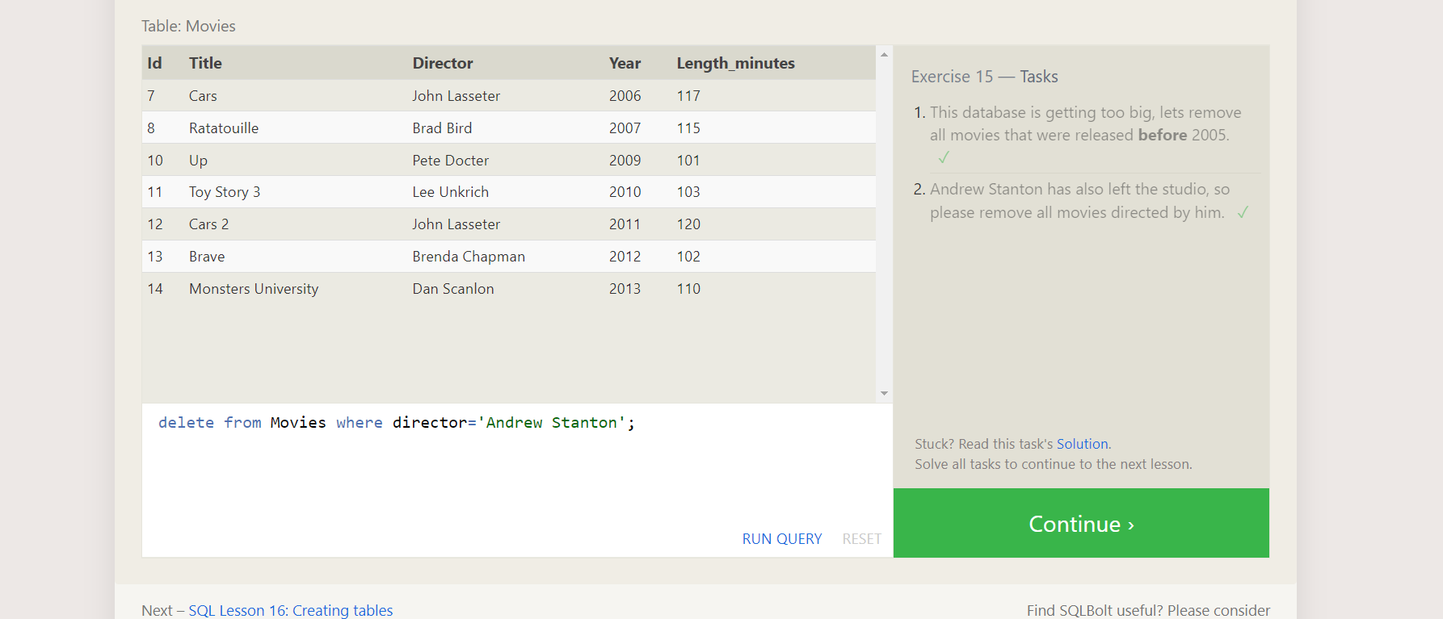

**SQL Lesson 16: Creating tables**

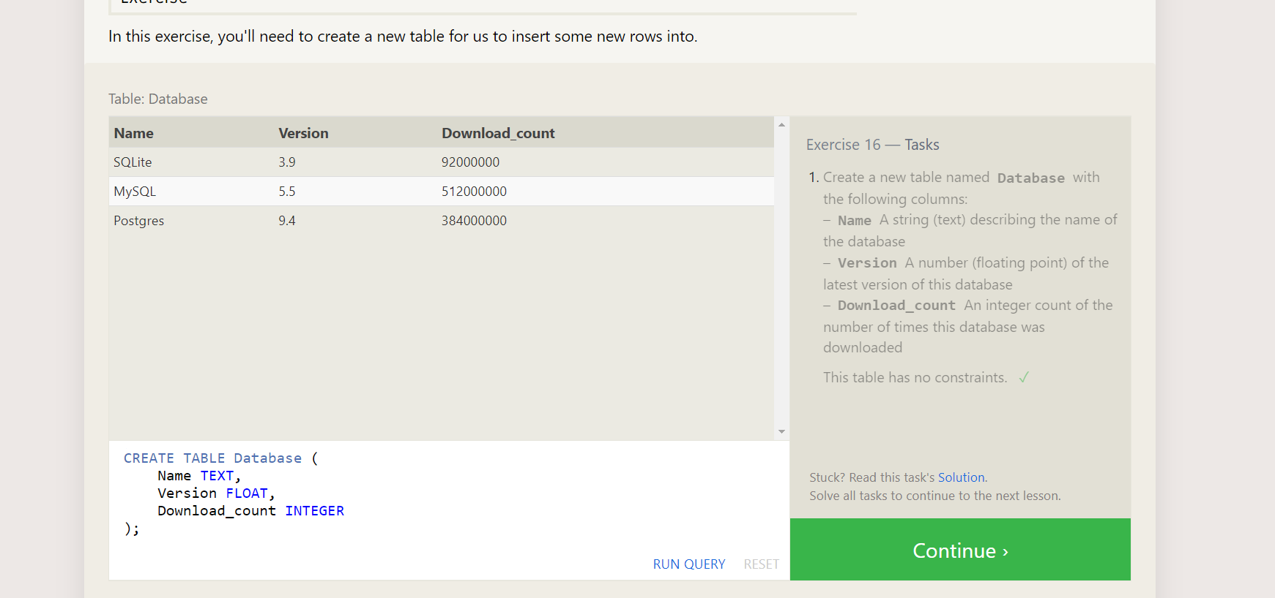

**SQL Lesson 17: Altering tables**

1. ALTER TABLE Movies

ADD COLUMN Aspect_ratio FLOAT DEFAULT 2.39;

2. ALTER TABLE Movies

ADD COLUMN Language TEXT DEFAULT "English";

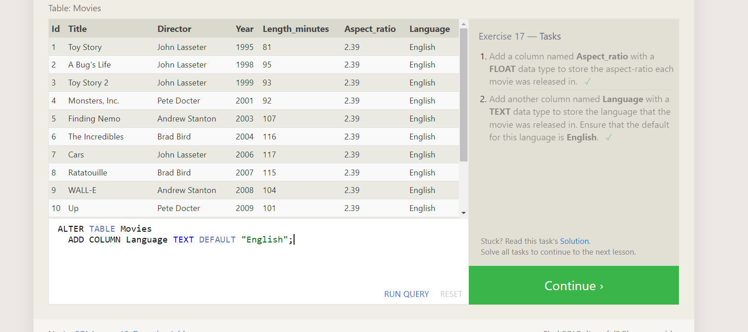

**SQL Lesson 18: Dropping tables**

1.DROP TABLE IF EXISTS Movies;

2. DROP TABLE IF EXISTS Boxoffice;

